LAB IMPLEMENTATION EXPERIMENT
Semantic Search using Embeddings and Vector Databases
Generative AI Laboratory (CO1, CO2)
Date: [Enter date of experiment / submission]
Aim
To build a semantic document-retrieval system by embedding BattingCoach project documentation, indexing the vectors with FAISS and retrieving the most relevant text chunks for natural-language queries.
Theory
Semantic search retrieves information according to meaning rather than exact word overlap. An embedding model maps each text chunk and query into a fixed-length numerical vector. Texts with related meaning tend to be close in the embedding space.
FAISS (Facebook AI Similarity Search) provides efficient nearest-neighbour search over dense vectors. ChromaDB is an alternative collection-oriented vector store that can also keep document text and metadata. For meaningful similarity comparisons, document embeddings and query embeddings must be generated by the same model and compatible preprocessing.
Cosine similarity measures the angle between two vectors. When embeddings are normalized to unit length, their inner product equals cosine similarity. A top-k retrieval operation returns the k most similar chunks. Similarity scores are ranking signals and should not be treated as calibrated probabilities or guaranteed relevance.
Dataset note: the notebook builds a source-labelled text collection from the BattingCoach README and related project facts, including MediaPipe pose estimation, YOLOv8-OBB bat detection, VideoMAE stroke classification and the 930-image Roboflow dataset. The raw image files are not embedded in this text-only retrieval demonstration.
Steps
1. Install Sentence Transformers and FAISS CPU (or use ChromaDB if selected).
2. Prepare at least five project-domain documents or 15–20 focused chunks, assigning each a unique ID and source title.
3. Clean the text and split long documents into manageable chunks. Preserve metadata such as source filename and section.
4. Load an approved embedding model such as all-MiniLM-L6-v2 and generate a vector for every chunk.
5. Record the embedding model name, vector dimension, number of chunks and output matrix shape.
6. Normalize vectors and create a FAISS inner-product index, or create a ChromaDB collection with the document text and metadata.
7. Embed each test query using the same embedding model and retrieve the top three relevant chunks.
8. Test direct questions, paraphrased questions and at least one unrelated query. Inspect the returned source text and similarity values.
9. Compare semantic retrieval with a simple keyword-based ranking method and record which approach retrieves more relevant evidence.
Code
Core implementation excerpt (the complete runnable workflow is provided in the corresponding notebook).
%pip -q install sentence-transformers faiss-cpu
from sentence_transformers import SentenceTransformer
import numpy as np, faiss
documents = [
{"id":"D1", "text":"BatCoach analyses batting biomechanics using MediaPipe 3D pose landmarks."},
{"id":"D2", "text":"YOLOv8-OBB detects cricket bats and estimates blade orientation."},
{"id":"D3", "text":"The Roboflow bat dataset contains 930 images in YOLOv8-OBB format."},
{"id":"D4", "text":"VideoMAE classifies ten cricket shots including cover, pull and sweep."},
{"id":"D5", "text":"Shadow practice suppresses bat-specific YOLO checks."}
]
model = SentenceTransformer("sentence-transformers/all-MiniLM-L6-v2")
texts = [d["text"] for d in documents]
vectors = model.encode(texts, normalize_embeddings=True).astype("float32")
index = faiss.IndexFlatIP(vectors.shape[1])
index.add(vectors)
def search(query, k=3):
q = model.encode([query], normalize_embeddings=True).astype("float32")
scores, ids = index.search(q, k)
return [(documents[i]["id"], float(s), documents[i]["text"])
for s, i in zip(scores[0], ids[0])]
print("Index size / dimension:", index.ntotal, index.d)
print(search("How does the system identify a bat's angle?"))
Output
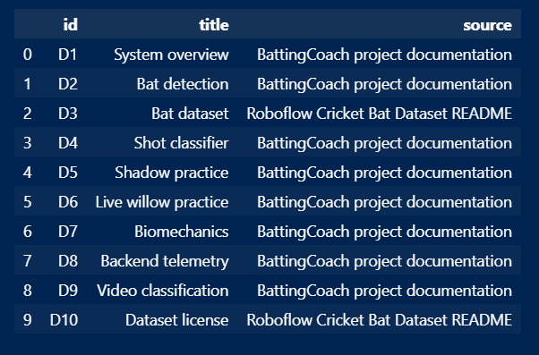

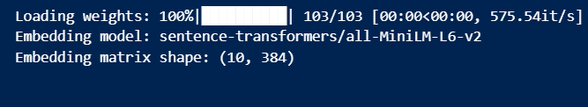

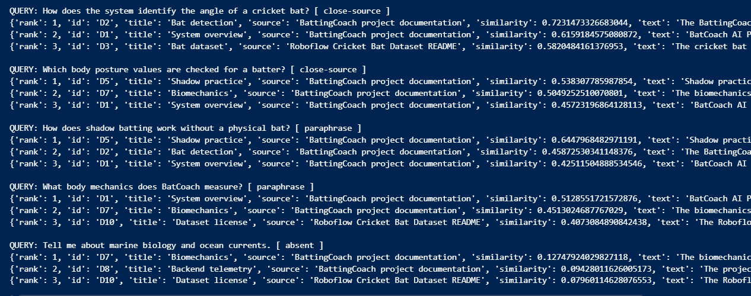

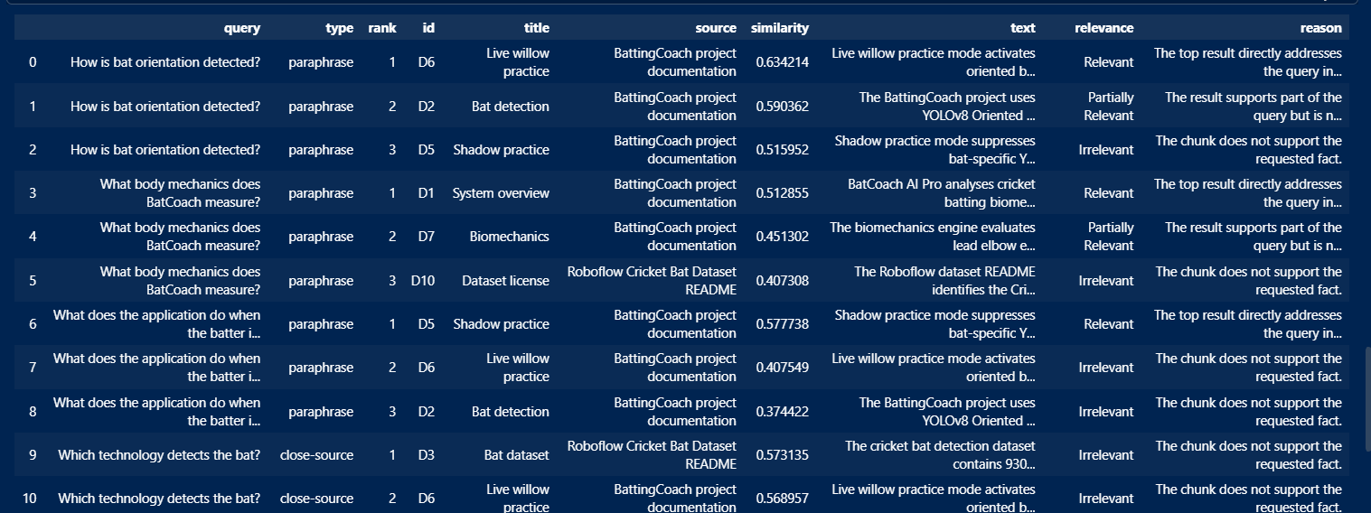

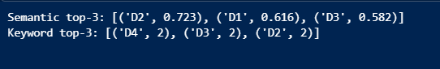

Observation
Record the document count, chunk count, embedding dimension, FAISS metric and top-k setting. For each query, mark retrieved chunks as relevant or irrelevant. Explain whether paraphrased questions were retrieved successfully and whether semantic retrieval improved over keyword matching.
Conclusion
The experiment demonstrates semantic search using vector embeddings and a FAISS index. BattingCoach documentation is represented as text chunks, transformed into vectors and searched using query embeddings. Complete the conclusion with the observed retrieval quality, embedding model details and examples of successful or weak matches.

